A New Scheme for Floating Energy Storage

Author: Chen Neng

Infiot@163.com

Introduction

The principle of a pumped storage power station is to pump water to a high place or discharge it to a low place, and store electrical energy by converting the gravitational potential energy of water into electrical energy. Can we change our mindset and see if there will be a significant change if we replace the water stored in a reservoir that moves up and down to store gravitational potential energy with a reservoir that moves up and down to store water?

Imagine a ten thousand ton ship floating on the sea, with valves installed at the bottom of the ship's hold. Open the valves and seawater flows into the hold, causing the ship to slowly sink into the water. When the ship is about to sink to the deck, close the water valves. Then reverse the operation, using a pump to discharge the water from the cabin, the ship will gradually float higher and higher. Install a hydroelectric generator at the valve in the cabin to generate electricity when the ship sinks, converting the ship's gravitational potential energy into electrical energy. When pumping water, electricity is consumed and converted into the gravitational potential energy of the ship. In order to save costs and improve efficiency, the giant ship was replaced with a large reservoir for water storage. The reservoir is shaped like a bucket and floats on the sea surface. The amount of water in the bucket is adjusted to control its float and sink, ultimately achieving energy storage similar to pumped storage power stations!

Based on the above concepts, the author has innovatively invented a buoyancy energy storage system solution. The design principle of this plan is now publicly disclosed to the society. This technical solution has never been used as a reference for similar implementation projects, and the feasibility, reliability, performance, cost, and other indicators of the solution are not yet clear. At the same time, the author's knowledge is limited, and there are inevitably many defects. Now, this immature solution is being proposed to attract criticism, correction, and improvement from people from all walks of life. I hope that this long-term, high-capacity, and low-cost energy storage technology roadmap can be implemented, contributing to solving the long-standing energy storage pain points in society, achieving the dual carbon goals, and ensuring national energy security.

Two power systems

Let's start with some basic concepts. A small physics experiment, a dry battery, a switch, a light bulb, several wires, close the switch, and the light bulb will light up. This includes the basic elements of the circuit: power supply, wires, switches, and loads. Draw the circuit diagram as follows:

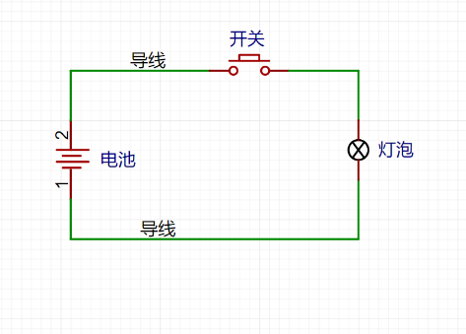

The power supply provides energy, the load consumes energy and converts it into various useful work. The switch controls the circuit on and off, and the wires connect various devices. By slightly converting the circuit, a simplified diagram of common mains power supply in daily life and production can be obtained:

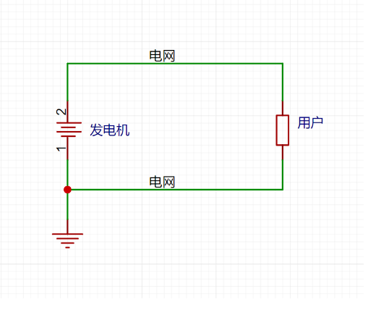

As shown in the figure, the electricity generated by the generator is transmitted to thousands of households through the power grid. In the diagram, the power grid is simplified into two wires and does not reflect parameters such as high and low voltage conversion, AC/DC conversion, etc. In fact, due to the geographical distribution between the power generation side and the user side, the power grid needs to deliver electrical energy to the user over long distances, with low losses, stable voltage, and stable frequency. However, in practical applications, there is a significant fluctuation in power between the power generation side and the user side. These fluctuations have a significant impact on the power grid.

For example, during the day when everyone goes out to work and study, the electrical appliances at home are basically turned off. At this time, the power consumption is very low. When you return home at night, you need to turn on the lights and various household appliances, and the power consumption will become very high. When everyone falls asleep at night, the power consumption will become very low again. Moreover, electricity consumption is greatly affected by the weather. When the weather is cold, you need to turn on the heating and hot water, and when the weather is hot, you need to turn on the fan and air conditioning, resulting in significant fluctuations in electricity consumption.

Similarly, the power generation side also faces various impacts. In addition to thermal power, the output power of nuclear power is relatively stable. Hydroelectric power is affected by the high and low water periods, while wind power and photovoltaic power are more affected by weather fluctuations.

In order to cope with the impact of power generation and consumption fluctuations on the power grid, China's energy structure has long been dominated by stable thermal power, paired with high-power and fast response hydropower, gas turbine power generation, and pumped storage power stations and other facilities to balance fluctuations.

Since the development of society, due to issues such as environmental protection, sustainable development, and energy security, the country has proposed the dual carbon target of peaking carbon emissions by 2030 and achieving carbon neutrality by 2060. The target requires that environmentally unfriendly power generation methods such as thermal power reduce their share year by year, while green energy sources such as wind power and optoelectronics gradually increase their share. However, the natural volatility of green electricity such as wind and solar power, as well as the frequent contradiction between wind and solar power curtailment and power shortage, pose new challenges in responding to changes in electricity energy. One of the main means to address these challenges is to increase energy storage.

Three energy storage systems

Let's first take a look at the schematic diagram of the role of energy storage devices in the power system:

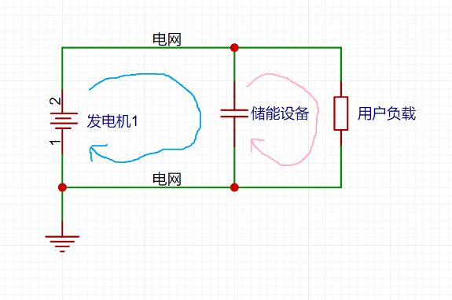

Taking the diagram as an example, when the power is stable, the power balance between the generation side and the consumption side is achieved, and the generation side directly supplies power to the user through the grid without the need for energy storage equipment to work. However, when the power generation side generates too much or the user side power is too low, the power generation equipment side cannot adjust the output power in a timely manner, and the remaining energy that cannot be consumed must be stored in the energy storage equipment (see blue energy storage charging circuit in the figure). When the power generation on the power generation side is too low or the power on the user side increases, the energy stored by the energy storage device can be timely output to supplement the insufficient power generation (see the pink energy storage discharge circuit in the figure). Simply put, if there is excess power in the power grid, it will be stored. If there is insufficient power in the power grid, it will be released, with more storage and less release, smoothing fluctuations, and regulating peak and frequency. This is the role of energy storage equipment in the power system.

With the increasing scale of grid connected installation of new energy sources such as wind and solar power, in order to overcome the intermittency and volatility of wind and solar power, the demand for supporting energy storage will increase significantly. The power system will also transition from the original "source grid load" to "source grid load storage", and energy storage is becoming the fourth basic element of new power systems.

According to the application scenarios of energy storage, it can be classified into three types: power generation side, grid side, and user side.

According to technical principles, it can be divided into three categories: energy storage, heat storage, and hydrogen storage. Among them, energy storage can be further divided into physical energy storage and chemical energy storage:

1. Physical energy storage: pumped storage, gravity storage, compressed air storage, flywheel storage, superconducting storage, and supercapacitor storage.
2. Chemical energy storage: lithium-ion batteries, lead-acid batteries, sodium based batteries, and flow batteries.

Among them, over 85% of China's installed energy storage capacity is pumped storage, and over 10% is lithium-ion battery storage. Although pumped storage has disadvantages such as difficult site selection, large one-time investment, and long construction period, its mature technology, low cost, long service life, large capacity, and high efficiency make it the absolute mainstay of energy storage. However, lithium-ion batteries have the advantages of high energy density and high efficiency. In recent years, due to the decrease in cost, lithium-ion battery energy storage has grown rapidly. However, battery manufacturing requires a large amount of rare metals, and there is a certain risk of fire and explosion during use. The disadvantages of complex protection circuits, high cost, low safety, and short cycle life still restrict the large-scale application of lithium-ion batteries.

Four types of buoyancy energy storage schemes

The basic principle of a buoyancy energy storage technology solution that can be found now is to install a traction motor or pulley group fixed at the bottom of the water to control the floating body to move up and down in the water to achieve energy storage. For example, Zhejiang University of Technology has applied for a patent for a new invention called "a buoyancy energy storage device that utilizes a reservoir.". The author believes that the manufacturing difficulty of the floating body in this scheme is relatively high, and it is necessary to solve the problems of the floating body's compressive strength and durability under low-cost conditions. Moreover, mechanical and electrical equipment requires fixed installation, which also restricts many application scenarios and further limits the increase in capacity. Overall, at the current industrial level, it is not possible to implement this plan on a low-cost and large-scale basis.

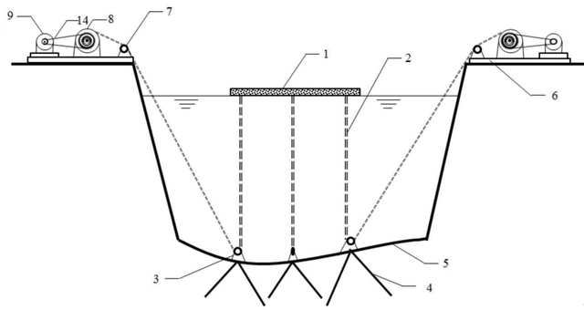Source: China National Intellectual Property Administration

This buoyancy energy storage scheme is different from the traction motor buoyancy energy storage scheme. The advantage is that there is no need for fixed devices, and the construction difficulty is low. The floating body is poured with reinforced concrete, which has strong compressive performance and low construction difficulty. The floating cylinder can be built and deployed on a large scale. Mechanical and electrical equipment can basically reuse the technology of pumped storage power stations. Overall, on the existing industrial foundation, there are no technical difficulties that are difficult to solve for float energy storage, and it has considerable feasibility.

Five new types of buoyancy energy storage

The set of buoyancy energy storage and pumped storage technologies proposed by the author belong to the same category of physical energy storage (essentially gravity energy storage), and are also charged and discharged through pumping and drainage. The difference is that pumped storage is the water in the reservoir as the energy storage body, while buoyancy energy storage is a floating cylindrical float as the energy storage body.

The design of buoyancy energy storage basically inherits the advantages of mature pumped storage technology, low cost, long lifespan, large capacity, long-term storage, fast response, and high efficiency. At the same time, it avoids the geographical location restrictions of high drop and abundant water required for pumped storage. In economically developed coastal areas, there are vast nearshore areas suitable for arranging buoyancy energy storage reservoirs. The float can be standardized and manufactured in a prefabricated factory base, and then pulled to a suitable water area for layout.

To simplify calculations, the float is designed as a hollow, bottom sealed, and cylindrical reinforced concrete structure. In this example, the design float has a radius of 200 meters, a height of 200 meters, a thickness of 1 meter, and a ballast stone filling ratio of 0.16. The following results were calculated:

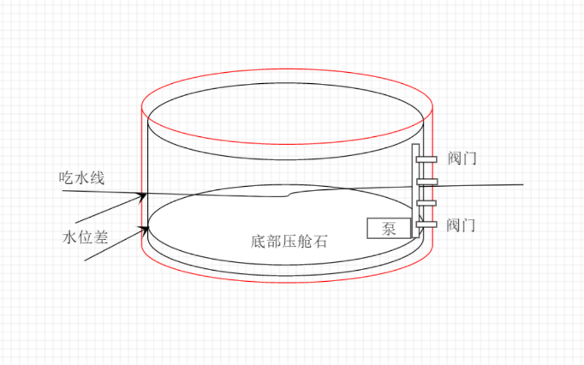

Float radius: 200.00 meters

Float height: 200.00 meters

Float thickness: 1.00 meters

Fill ratio: 0.16

Concrete volume: 374918.00 cubic meters (374900 cubic meters)

Concrete quality: 937295.00 tons (937300 tons)

Concrete cost: 374918016.00 yuan (374.918 million yuan) (375 million yuan)

Filling soil height: 32.00 meters

Quality of filled soil: 9947772.00 tons (9.9478 million tons)

Total weight: 10885067.00 tons (10.8851 million tons)

Draft depth: 86.66 meters

Internal and external water pressure difference: 54.66 meters

Power generation: 1208990.88 kWh (1.209 million kWh)

Investment cost per kilowatt hour of construction: 310.11 yuan

Note that only the concrete construction cost, which accounts for the largest share of the investment cost per kilowatt hour, is considered in the construction cost. Other costs (such as the filling cost of ballast stones, the cost of mechanical and electrical equipment such as water pumps, generators, distribution cabinets, cables, valves and pipelines, production costs, etc.) are not included in the calculation. Therefore, this calculation result is only applicable for estimating cost-benefit and serves as an investment reference.

The formula code used in the calculation is placed at the end of this article. If interested, you can use the code to verify the cost of different sizes.

After trying various sizes, it was found that increasing the radius, increasing the height, and reducing the thickness can greatly reduce the unit construction cost, even to the level of one hundred yuan. Even with the cost of ballast stones, mechanical and electrical equipment, this price is not inferior to the cost of pumped storage per kilowatt hour, let alone the current investment cost of one or two thousand yuan per kilowatt hour of lithium-ion battery energy storage.

However, increasing the radius and excessive volume may lead to instability in the structure of the buoy, requiring the addition of a large number of supporting beams internally, ultimately resulting in a complex structure and a significant increase in construction costs. If the water pressure difference between the inside and outside of the float is too large, the pressure on the float wall may be too high, which may cause the wall to collapse. In order to simplify the design, the above relatively moderate sizes were used.

Six Characteristics

Economy often determines the survival of an energy storage project. Although the price of lithium-ion batteries has significantly decreased in recent years, the investment cost per kilowatt hour of lithium-ion energy storage power stations is still as high as around 2000 yuan.

The investment cost per kilowatt hour of pumped storage energy is based on the example of the largest Fengning pumped storage power station in China, which can store 40 million kilowatt hours of electricity and has an installed power of 3.6 million kilowatts, with a total investment of 19.2 billion yuan. It can be calculated that: total investment/energy storage capacity=investment cost per kilowatt hour.

1920000000/40000000=480 yuan (investment cost per kilowatt hour)

Overall, the investment cost per kilowatt hour of pumped storage is currently the lowest, while the investment cost per kilowatt hour of lithium-ion battery energy storage ranges from 1000 to 2000. However, its performance and application scenarios are relatively superior. The investment cost per kilowatt hour of other new energy storage methods is currently generally higher than that of lithium-ion battery energy storage. So pumped storage and lithium-ion battery energy storage account for the largest share of energy storage and correspond to their investment cost per kilowatt hour.

The previous calculation shows that the investment cost per kilowatt hour of the new buoyancy energy storage scheme is 310 yuan. It is believed that after various optimizations, there is still a lot of room for cost reduction in kilowatt hours of electricity. For example, the cost of concrete is calculated at 1000 yuan per cubic meter, which is higher than the general unit price of high-grade concrete, and there should be some room for decline. The efficiency of each energy storage cycle is calculated at 60%, which is relatively conservative and low. Taking the efficiency of modern pumped storage power stations as a benchmark of 70% -80%, there is significant room for improvement in efficiency.

One idea is to convert the billions of tons of construction waste generated in China each year into ballast stones, which account for the largest proportion of float quality. This will turn waste into treasure and also solve the problem of private dumping of construction waste in urban management. It has considerable objective management value and environmental ecological value. So the cost of the ballast stone here will be offset first.

The cost of other water pumps, valves, pipelines, cables, production and manufacturing is roughly estimated to be about half of the building investment cost of 310 yuan per kilowatt hour, which is 150 yuan. Overall, the investment cost per kilowatt hour is 460 yuan. Compared to the investment cost of 480 yuan per kilowatt hour for pumped storage power stations, it is not inferior and has considerable investment value.

Capacity wise, according to previous calculations, a buoy with a radius of 200 meters can store 1.2 million kilowatt hours (1.2GWh) of electrical energy. Changing the size of the float can easily alter its capacitance. Even if the electrical capacity of a single buoy is not large enough, it is still convenient to increase the total capacity by arranging multiple buoy combinations.

Power efficiency, by increasing or decreasing the number of water pumps and valves, can easily adjust the electrical power of the float. However, the number of valves may affect the structural stability of the float. The increase in water pumps will also lead to an increase in investment costs. So, regarding the issue of power, more information needs to be collected and simulation models established to obtain more economical and practical electrical power values.

In terms of application scenarios, compared to the problem of selecting a location for pumped storage power stations, the location for float energy storage is in the vast ocean and will not occupy valuable land resources. In consideration of water depth, navigation channel, economic development and other factors, the open sea opposite Zhoushan Islands and the sea near the Dongsha Islands can be considered. The water depth should not be too shallow, far from ocean routes, and close to economically developed areas in the Yangtze River Delta and Pearl River Delta.

The investment, capacity, power and other indicators of this plan far exceed those of ordinary user side energy storage projects, so this plan belongs to the category of grid side energy storage and should be implemented by the national team or the lead. I believe that with China's current infrastructure capabilities, it is not difficult to achieve this project. For example, the newly opened Shenzhong Channel, 80000 ton sunken pipes, and a hundred meter high bridge are worthy of the title of infrastructure maniac!

Seven topics

The author's level is limited, and there are still several topics to be improved. The following are proposed:

1. The water pressure difference between the inside and outside of the float is several tens of meters high. How much pressure can the float wall resist? Do you want to use high-grade concrete?

Will the buoy deviate from its position due to the influence of wind and ocean currents? Do you need to use anchor chains to fix it to the seabed?

Will the strong winds and waves brought by the typhoon season damage the buoy? Should the float be changed to a hyperbolic shape to enhance its compressive strength?

Is it feasible to adopt a semi submersible float or even sit on the seabed to avoid adverse weather conditions such as typhoons, and use compressed air to float up after the typhoon?

1. The selection of parameters for electromechanical equipment.
2. The impact of waterway safety (including surface and underwater).
3. The impact of other energy storage technologies.
4. The impact of market investment.
5. The impact of national policies.
6. The impact of marine ecology.
7. The issue of maritime rights and territorial issues.

Eight codes

The C language code is as follows. You can use online tools to run the code, modify the radius, height, thickness, proportion, and other numerical values in the first few lines of the code, and obtain different calculation results.

Online tool link https://www.jyshare.com/compile/11/

**************************************Code Splitting Line************************************

#include <stdio.h>

#define pi 3.14f

//Dimensions in meters

static float R = 200; // radius

static float H = 200; // height

//static float T = 0.8f; // Thickness (decimal) (double slash before//indicates not using the value in that row)

static float T = 1; // Thickness (integer) (double slash before//indicates not using the value of that line)

static float P = 0.16f; // The percentage of filled soil to height H

//Concrete volume

static float V_hnt (void)

{

return ((pi*R*R*H) - (pi*(R-T)*(R-T)*(H-T)));

}

//Concrete quality

static float M_hnt (void)

{

return (V_hnt()*2.5f);

}

//Cost

static float Cost_hnt (void)

{

return (V_hnt()*1000);

}

//Soil filling quality (ballast stone)

static float M_tc (void)

{

return ((pi*(R-T)*(R-T)*(H*P))*2.5f);

}

//Total mass

static float M (void)

{

return (M_hnt() + M_tc());

}

//Draft depth

static float Hcs (void)

{

return (M()/(pi*R*R*1));

}

//Internal and external water pressure difference (head)

static float Hst (void)

{

return (Hcs() - H*P);

}

//Sports height

static float Hy (void)

{

return (H - Hcs());

}

//Energy

static float PE (void)

{

return ((M()*1000*9.8f*Hy())/3600000*0.6f*0.6f);

}

//Unit cost

static float Unit_cost (void)

{

return (Cost_hnt()/PE());

}

int main()

{

printf("*******************************************************\r\n");

Printf ("Float radius:%. 2f meters \ r \ n", R);

Printf ("Float height:%. 2f meters \ r \ n", H);

Printf ("Float thickness:%. 2f meters \ r \ n", T);

Printf ("Fill percentage:%. 2f \ r \ n", P);

printf("\r\n");

Printf ("Concrete volume:%. 2f cubic meters", V_hnt());

Printf ("% 2000 cubic meters) \ r \ n", V_hnt()/10000);

Printf ("Concrete mass:%. 2f tons", Mnnt());

Printf ("% 2000 tons) \ r \ n", Mnnt()/10000);

printf("\r\n");

Printf ("Concrete cost:%. 2f yuan", Cost_hnt());

Printf (% 20000 yuan), Cost_hnt()/10000 yuan);

Printf ("% 2f billion yuan) \ r \ n", Cost_hnt()/10000/10000);

printf("\r\n");

Printf ("Fill soil height:%. 2f meters \ r \ n", H * P);

Printf ("Mass of filled soil:%. 2f tons", Mttc());

Printf ("% 2000 tons) \ r \ n", Mttc()/10000);

printf("\r\n");

Printf ("Total mass:%. 2f tons", M());

Printf ("%. 2 million tons) \ r \ n", M()/10000);

printf("\r\n");

Printf ("Draft:%. 2f meters \ r \ n", Hcs());

Printf ("Internal and external water pressure difference:%. 2f meters \ r \ n", Hst());

printf("\r\n");

Printf ("Power generation:%. 2f kWh", PE());

Printf ("(% 2f degrees) \ r \ n", PE()/10000);

printf("\r\n");

Printf ("Investment cost per kilowatt hour:%. 2f yuan \ r \ n", Unit_cost());

printf("******** ****************************************** *****\r\n");

return 0;

}

*******************************************Code Splitting Line***************************************

Author: Chen Neng

Time: June 30th, 2024